‘Meet and Mix’ is the new name for CPBC’s Sunday Afternoon Group.

Date | Where? | Info
Sunday 20 Oct  2pm (after morning service and church members’ meeting) | Meal out at Coco Buffet James Street   | Meal £17.99, plus any drink.  Sign up at church or ring David J.
Sunday 10 Nov |   Cinema  Film, place and times to be confirmed
Tuesday 3 Dec  6.30 – 9pm  CPBC |   Carols Around the Christmas Tree | Refreshments, activities and carol singing.  Wear warm clothes!
Saturday 7 Dec  2 - 5pm  CPBC | CPBC Christmas Party   | Bring food to share at teatime.  Games, chat and fun!
Sunday 8 Dec  5pm at Bay Café @ The Tropicana | Christmas Carvery  at The Bay Café (Tropicana)  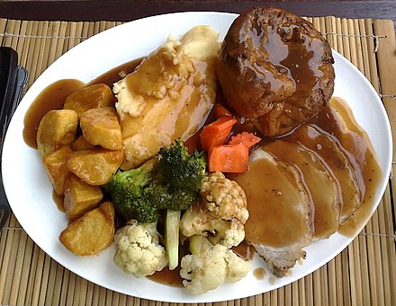 | Choice of carvery £15.99 large  £12.99 standard  £10.99 child/ 60+  Plus drink  Sign up at church or let Su know
Sunday 22 Dec  6.30  CPBC | Carols by Candlelight    This Photo by Unknown Author is licensed under CC BY-NC-ND | Carols, Christmas readings, followed by refreshments.
Christmas Day  10.30  CPBC |   Christmas Morning Service | Short service on Christmas morning. All welcome!

‘Meet and Mix’ is a monthly CPBC social meet-up, usually on a Sunday Afternoon. Everyone - and anyone - is welcome!
We plan the group together; and like doing activities where we can chat and spend time together. Many – but not all - of our members have a learning difficulty, are neuro-diverse or another additional need.
Our faith is important to us: we are friends and help and support each other. Sometimes we pray together. We welcome others from CPBC and Weston Baptist Churches to join us. Our other friends are also welcome, because we would like them to know God too.
We enjoy being part of CPBC services and groups e.g. Men’s Group, So Crafty, Community Coffee Morning, Ladies’ Fellowship etc. We like taking part in church services e.g. doing Bible readings, playing the piano, praying, helping with refreshments, and helping organise and plan. You will also find us visiting other Weston Baptist Churches for special events or speakers, and coffee mornings!
Join us at our Meet and Mix events! All welcome……….
Questions or ideas?
Ring Su: 0791 646 1442
email su.weeks@cpbc.co.uk

